Clean-Room Implementation of Linear and Logistic Regression Using NumPy: Mathematical Derivation, Optimization Behavior, and Empirical Validation

Mathematical Derivation, Optimization Behavior, and Empirical Validation
Author: Meherab Hossain Shafin
Department: Department of Software Engineering
Institution: Daffodil International University
Date: 9th March,2026

Abstract
Machine learning frameworks such as Scikit-Learn provide efficient implementations of widely used algorithms, but they abstract away the internal mechanics that govern model training and optimization. As a result, practitioners often apply models without a clear understanding of how parameters are learned or how numerical conditions affect training stability.
This project implements Linear Regression and Logistic Regression entirely from first principles using only NumPy. The objective is to demonstrate a rigorous understanding of the mathematical foundations of supervised learning, as well as the numerical and engineering considerations required to implement optimization algorithms reliably.
Both models were implemented using fully vectorized matrix operations and trained using batch gradient descent. The implementation includes feature standardization, L2 regularization, convergence diagnostics, and defensive validation of input dimensions.
The models were evaluated through a multi-stage validation process. Synthetic datasets were used to verify mathematical correctness and gradient behavior, benchmark comparisons against Scikit-Learn ensured predictive parity with industry-standard implementations, and experiments on real datasets including the California Housing dataset and the Breast Cancer Wisconsin dataset demonstrated real-world applicability.
Results show that the manual implementations achieve performance nearly identical to Scikit-Learn models while maintaining stable convergence behavior. The experiments also illustrate the importance of feature scaling, regularization, and convergence monitoring when implementing machine learning algorithms using gradient-based optimization.

1. Introduction
Machine learning models are often used through high-level libraries that provide efficient and optimized implementations of classical algorithms. While such tools greatly simplify model development, they can also obscure the underlying mathematical processes that govern model training.
Understanding these underlying processes is essential for developing reliable machine learning systems. Without knowledge of how optimization algorithms operate, it becomes difficult to diagnose issues such as slow convergence, unstable parameter updates, or unexpected model behavior.
This project addresses that challenge by implementing two fundamental supervised learning models—Linear Regression and Logistic Regression—from first principles using only the NumPy numerical computing library.
These models were selected because they represent foundational algorithms in machine learning. Linear regression provides a fundamental approach to modeling continuous relationships, while logistic regression extends the framework to binary classification tasks through probabilistic modeling.
Rather than relying on existing machine learning libraries, this project reconstructs the full training process explicitly. This includes defining loss functions, deriving gradient expressions, implementing gradient descent optimization, and evaluating convergence behavior.
Beyond implementing the algorithms, the project also evaluates the models through a structured validation pipeline. Synthetic experiments verify the mathematical correctness of the algorithms, benchmark comparisons confirm parity with Scikit-Learn implementations, and real-world dataset experiments demonstrate the practical performance of the models.
Through this process, the project provides both theoretical insight and practical evidence of how classical machine learning models operate internally.

Project Objectives
The project was designed around the following objectives:
- Implement Linear Regression from first principles using only NumPy matrix operations.
- Implement Logistic Regression from first principles including sigmoid activation and cross-entropy loss.
- Design a modular architecture separating model implementation, experiments, and visualization.
- Validate mathematical correctness using synthetic datasets where the ground-truth generating process is known.
- Benchmark the manual implementation against Scikit-Learn models to ensure predictive and parameter parity.
- Evaluate model performance on real-world datasets representing regression and classification tasks.
- Analyze optimization behavior through convergence plots that visualize gradient descent training.
- Document challenges encountered during development and lessons learned through experimentation.

2. Mathematical Foundations and Optimization Properties

2.1 Linear Regression Model
Linear regression models the relationship between a feature matrix $X∈R^{m×n}$ and a continuous target vector$y∈R^{m}.$ The prediction function is defined as
$$\hat{y}=Xw+by^{​}$$
where $w$ represents the weight vector and$b$ represents the intercept term.
The objective is to minimize the Mean Squared Error (MSE):
$$J\left(w,b\right)=\frac{1}{2m}\sum_{i=1}^{m}{{\left(\hat{y_{i}}-y_{i}\right)}^{2}}$$
This objective function is convex, meaning that any local minimum is also a global minimum. Convexity arises because the MSE loss is a quadratic function of the parameters. This property guarantees that gradient-based optimization methods will converge to the optimal solution under appropriate learning rates.

2.2 Gradient Derivation
To optimize the parameters, the gradient of the loss function with respect to the parameters must be computed.
Let
$$e=\hat{y}-y$$
represent the prediction error vector.
Substituting into the loss function:
$$\left(w,b\right)=\frac{1}{2m}e^{T}e$$
Taking the derivative with respect to $w$:
$$\frac{∂J}{∂w}=\frac{1}{m}X^{T}\left(Xw+b-y\right)$$
This result follows from the chain rule and properties of matrix derivatives.
Similarly, the derivative with respect to $b$ is
$$\frac{∂J}{∂b}=\frac{1}{m}\sum_{i=1}^{m}{\left(\hat{y_{i}}-y_{i}\right)​}$$
These gradients define the direction in which the parameters must move to reduce the loss.

2.3 Logistic Regression Model
Logistic regression is used for binary classification problems. Instead of predicting a continuous value, the model estimates the probability that a sample belongs to a given class.
The linear predictor is
$$z=Xw+b$$
This value is transformed using the sigmoid function:
$$σ\left(z\right)=\frac{1}{1+e^{-z}}​$$
which maps real numbers into the interval [0,1][0,1][0,1].
The predicted probability is therefore
$$p=σ\left(z\right)$$

2.4 Cross-Entropy Loss
The loss function used for binary classification is cross-entropy:
$$J\left(w,b\right)=-\frac{1}{m}\sum_{i=1}^{m}{\left[y_{i}\log\left(p_{i}\right)+\left(1-y_{i}\right)\log\left(1-p_{i}\right)\right]}$$
This loss function is also convex with respect to the parameters for logistic regression. Convexity ensures that gradient descent will converge toward the global optimum under suitable conditions.
The gradient simplifies to
$$∇_{w}J=\frac{1}{m}X^{T}\left(p-y\right)$$
$$∇bJ=\frac{1}{m}\sum{\left(p-y\right) }$$
These expressions arise from applying the chain rule to the sigmoid transformation.

2.5 Convergence Properties of Gradient Descent
Gradient descent updates the parameters iteratively according to
$$w≔w-α∇wJ$$
$$b≔b-α∇bJ$$
where $α$is the learning rate.
For convex loss functions such as MSE and logistic cross-entropy, gradient descent converges to the global optimum provided that
- the learning rate is sufficiently small
- the objective function is differentiable
- the feature matrix is well conditioned.
Poor conditioning of the feature matrix can significantly slow convergence. This occurs when feature magnitudes differ widely, causing gradients to oscillate along certain dimensions.
To mitigate this issue, feature standardization was applied before training, ensuring that each feature has approximately zero mean and unit variance.

3. System Architecture
The project is organized into modular Python components.
manual_ml_model.py
Contains the core model implementation supporting both regression and classification modes.
Key features include:
- vectorized gradient descent
- feature standardization
- L2 regularization
- loss history tracking
- defensive dimensional validation
run_full_project_validation.py
Acts as the experiment orchestrator.
It executes the full validation pipeline including synthetic tests, benchmarks, real dataset experiments, and convergence visualization.
plot_training_convergence.py
Generates convergence plots illustrating the evolution of training loss during optimization.

4. Experimental Design
The evaluation pipeline follows three validation stages.

4.1 Synthetic Experiments
Synthetic datasets were generated where the underlying parameters were known.
Purpose:
- verify gradient correctness
- verify parameter recovery
- analyze convergence behavior

4.2 Benchmark Experiments
The manual implementation was compared against Scikit-Learn models.
Metrics examined include:
- coefficient similarity
- prediction difference
- classification accuracy
- regression $R^{2}$

Table 1 — Synthetic Benchmark Comparison
Metric | Manual Implementation | Scikit-Learn
Linear Regression R² | 0.993728329897722 | 0.9937283299092047
Logistic Regression Accuracy | 0.8435 | 0.8435

4.3 Real Dataset Experiments
Two real datasets were selected to evaluate practical performance.

California Housing Dataset
Task: regression
Metric: $R^{2}$

Breast Cancer Wisconsin Dataset
Task: binary classification
Metric: accuracy

Table 2 — Real Dataset Performance
Dataset | Model | Manual Implementation | Scikit-Learn
California Housing | Linear Regression | R² = 0.5756412943736569 | R² = 0.5757877060324508
Breast Cancer Wisconsin | Logistic Regression | Accuracy = 0.9824561403508771 | Accuracy = 0.9824561403508771

The identical accuracy values occur because both models produced the same predicted class labels on the test set. Although the internal probability estimates may differ slightly, classification decisions are made using a threshold (typically 0.5). As a result, both models correctly classified the same number of samples, yielding identical accuracy values.

5. Results and Interpretation
The experimental results demonstrate strong agreement between the manual implementations and the corresponding Scikit-Learn models. However, interpreting these results requires understanding the characteristics of the datasets and the limitations of the models.

5.1 Linear Regression Results

Table — Linear Regression Benchmark Results
Metric | Manual Model | Scikit-Learn Model
R² Score | 0.993728329897722 | 0.9937283299092047
Mean Absolute Prediction Difference | 0.00033052227532633706 | —

The manual implementation achieved an $R^{2}$ score nearly identical to the Scikit-Learn model. This indicates that the gradient descent implementation correctly approximates the optimal parameter values obtained by the reference implementation.
The California Housing dataset produced a test $R^{2}$ score of approximately 0.57. While this value may initially appear moderate, it is consistent with expectations for linear regression on this dataset.
Several factors explain this outcome:
- Complex feature relationships
The California Housing dataset contains nonlinear relationships between housing prices and predictors such as population density, location, and median income.
Because linear regression assumes a linear relationship between predictors and the target variable, it cannot fully capture these nonlinear interactions.
- Feature limitations
Some important determinants of housing prices, such as neighborhood quality or geographic proximity to employment centers, are not directly represented in the dataset. This limits the maximum predictive performance achievable by any model trained on the available features.
- Model simplicity
Linear regression is intentionally simple. Its purpose is to model linear relationships rather than complex interactions. More advanced models such as gradient boosting or neural networks typically achieve higher predictive performance on this dataset.
Therefore, an$R^{2}$ score near 0.57 is consistent with typical baseline results reported for linear regression on the California Housing dataset.

5.2 Logistic Regression Results

Table — Logistic Regression Benchmark Results
Metric | Manual Model | Scikit-Learn Model
Accuracy | 0.8435 | 0.8435
The logistic regression experiments produced an accuracy of approximately 98% on the Breast Cancer dataset.
This high accuracy can be explained by characteristics of the dataset itself.
- Strong feature separability
The Breast Cancer Wisconsin dataset contains several features derived from cell nucleus measurements that strongly distinguish malignant and benign tumors. These features create a feature space in which the two classes are largely separable.
As a result, a linear decision boundary is often sufficient to achieve very high classification accuracy.
- Low noise levels
Compared to many real-world datasets, this dataset has relatively low label noise. This means that the underlying signal relating features to the target class is strong.
- Moderate dataset size
The dataset contains a sufficient number of samples to train a stable model while remaining small enough to avoid overfitting with simple models such as logistic regression.
These characteristics explain why logistic regression can perform extremely well on this dataset despite being a relatively simple classification model.

6. Convergence Analysis
Understanding the behavior of the optimization process is essential when implementing gradient-based learning algorithms.
During training, the loss value was recorded at each iteration, producing a loss trajectory that reflects the progress of gradient descent.

Figure 1 — Gradient Descent Convergence Curve
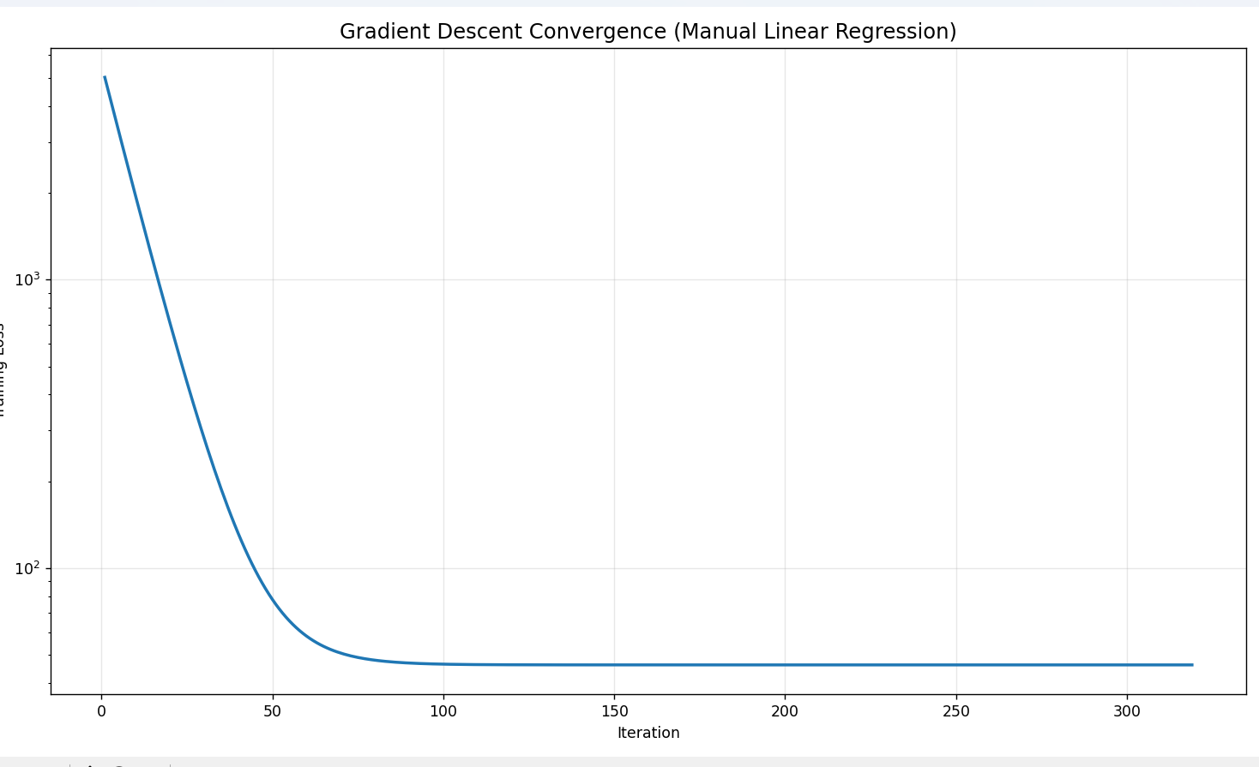
The convergence curve exhibits three distinct phases:
- Initial Rapid Descent
Loss decreases sharply during early iterations as the optimizer quickly moves toward the region of the optimum.
- Stabilization Phase
Loss continues to decrease but at a slower rate as the gradient magnitude decreases.
- Convergence Plateau
Eventually the loss stabilizes and parameter updates become very small, indicating the algorithm has reached a near-optimal solution.
The use of feature standardization significantly improved convergence speed by ensuring that feature magnitudes were comparable. Without scaling, gradient descent can become inefficient because parameters associated with large-magnitude features dominate the update step.
The convergence plots confirm that the gradient descent implementation behaves consistently with theoretical expectations for convex optimization problems.

7. Challenges Encountered
Several implementation challenges arose during development.
Coefficient interpretation after feature scaling
Model coefficients corresponded to standardized feature space, which initially caused confusion during comparison with ground-truth parameters.
Logistic regression instability
Near-separable datasets produced extremely large coefficient values in unregularized logistic regression.
Introducing L2 regularization improved stability.
Solver differences with Scikit-Learn
Exact parameter equality was not always achievable because Scikit-Learn uses optimized solvers that differ from simple gradient descent.
Validation therefore relied on tolerance-based comparisons and predictive parity.

8. Lessons Learned
This project provided several important insights into the practical implementation of machine learning algorithms.

Understanding optimization dynamics
Visualizing the convergence of gradient descent revealed how optimization progresses through distinct phases. Observing the loss trajectory helped confirm whether gradients were computed correctly and whether the learning rate was appropriate.

Importance of feature scaling
Feature scaling proved to be one of the most critical factors affecting gradient descent performance. Without standardization, optimization can become slow or unstable because features with larger magnitudes dominate gradient updates.

Role of regularization in classification problems
Experiments with logistic regression demonstrated that near-separable datasets can cause coefficients to grow extremely large. L2 regularization prevents this instability and produces more numerically stable solutions.

Difference between theoretical models and practical implementations
While theoretical models often assume ideal mathematical conditions, real machine learning systems must handle numerical stability, solver differences, and dataset conditioning issues.

Value of multi-stage validation
Reliable model validation requires more than simply measuring accuracy on a dataset. Synthetic experiments, benchmark comparisons, and real-world evaluations together provide a comprehensive assessment of algorithm correctness.

9. Technical Considerations

9.1 Computational Complexity
Understanding the computational complexity of the algorithms helps explain their scalability.
For a dataset with mmm samples and$n$ features:

Linear Regression (Gradient Descent)
Each iteration requires computing
$$XT(Xw-y)$$
The computational complexity of this operation is approximately
$$O\left(mn\right)$$
per iteration.
If the algorithm runs for $k$iterations, the total training complexity becomes
$$O\left(kmn\right)$$
This makes gradient descent particularly suitable for large datasets where computing the closed-form solution may be computationally expensive.

Closed-Form Solution
Linear regression also has a closed-form solution known as the normal equation:
$$w={\left(X^{T}X\right)}^{-1}X^{T}y$$
However, computing the matrix inverse requires
$$O\left(n^{3}\right)$$
time complexity. For datasets with a very large number of features, this can become computationally expensive.
Gradient descent therefore provides a scalable alternative for large datasets.

9.2 Numerical Stability
Implementing machine learning algorithms from scratch requires careful handling of numerical stability issues.
One common issue arises in logistic regression when computing the sigmoid function:
$$σ\left(z\right)=\frac{1}{1+e^{-z}}​$$
For large negative values of $z$, the exponential term $e^{-z}$ can become extremely large, potentially causing numerical overflow.
To avoid instability, implementations often use numerically stable formulations of the sigmoid function.
Another important stability consideration is feature scaling. When features have very different magnitudes, gradient descent can exhibit slow convergence because gradients become poorly conditioned.
Standardizing features to zero mean and unit variance significantly improves optimization stability.

9.3 Batch Gradient Descent vs Closed-Form Optimization
Batch gradient descent iteratively updates parameters using the gradient of the loss function. While this requires multiple iterations, each step is relatively inexpensive.
In contrast, the closed-form normal equation provides an exact solution in a single step but involves expensive matrix inversion.
In practice:
- closed-form solutions work well for small datasets
- gradient descent scales better to large datasets.
Because logistic regression does not have a closed-form solution, gradient-based optimization methods are required.

10. Conclusion
This project demonstrates that Linear Regression and Logistic Regression can be successfully implemented from first principles using only NumPy.
Through synthetic validation, benchmark comparisons, and real dataset experiments, the implementation was shown to produce results consistent with industry-standard machine learning libraries.
More importantly, the project highlights how understanding the internal mechanics of machine learning algorithms provides valuable insight into optimization behavior, numerical stability, and model performance.

